68Everything you need for a perfect stay, beautifully organized.
7405 Bovet Way, San Diego, CA 92122, USA

Welcome to your home away from home in the peaceful University City neighborhood of San Diego.
This charming single-family residence offers the perfect balance of comfort, privacy, and convenience—ideal for families, business travelers, or small groups looking to enjoy San Diego like a local.

(Airbnb Link for Photos: https://www.airbnb.com/rooms/830412861545540206?)

🏡 Property Overview

🌟 What Guests Love
Quiet, safe residential neighborhood—great for relaxing stays
Easy self check-in process for flexible arrival
Close to UCSD, La Jolla, and Sorrento Valley
About 10 minutes to the beach and major attractions
Access to amenities like living room, backyard, and more

📍 Location Highlights
Nestled in University City, known for being safe and family-friendly
Quick access to I-5 and I-805
Minutes from:
🏖️ La Jolla Shores & beaches
🛍️ Westfield UTC Mall
🎓 UC San Diego
🍽️ Restaurants & cafes

📍 Finding the Home
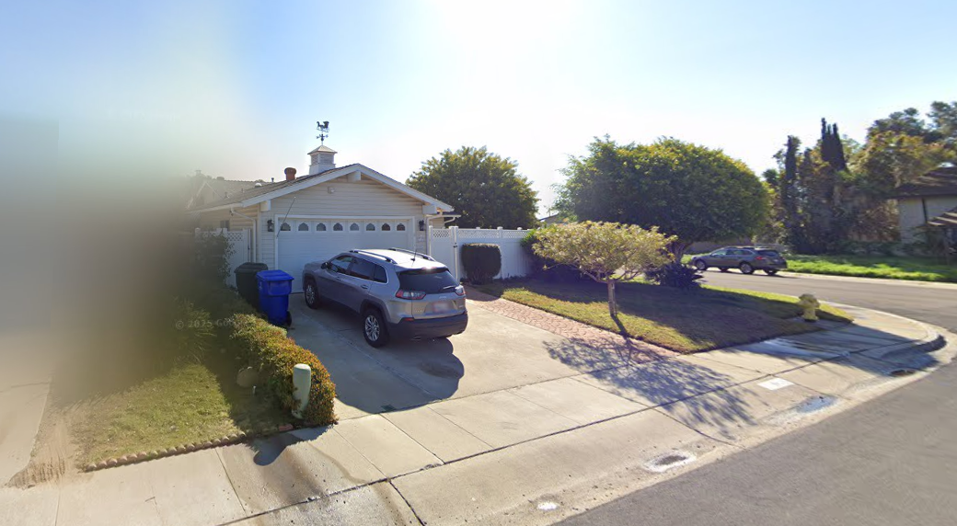

- Look for 7405 Bovet Way clearly marked on the house or curb
- The home is located on a quiet residential street in University City
- Please drive slowly and be mindful of neighbors

Aerial Photo:
https://prnt.sc/oeoygXZW94iZ

Driving Directions:

From Interstate 5 (I-5)
- Take Exit 29 for Genesee Avenue / La Jolla Village Drive
- Head east on Genesee Avenue toward University City
- Turn left onto Governor Drive
- Turn left onto Gullstrand Street
- Turn right onto Florey Street
- Turn left onto Bovet Way
- The home will be on your left
👉 This is one of the most direct and commonly used routes to the property.

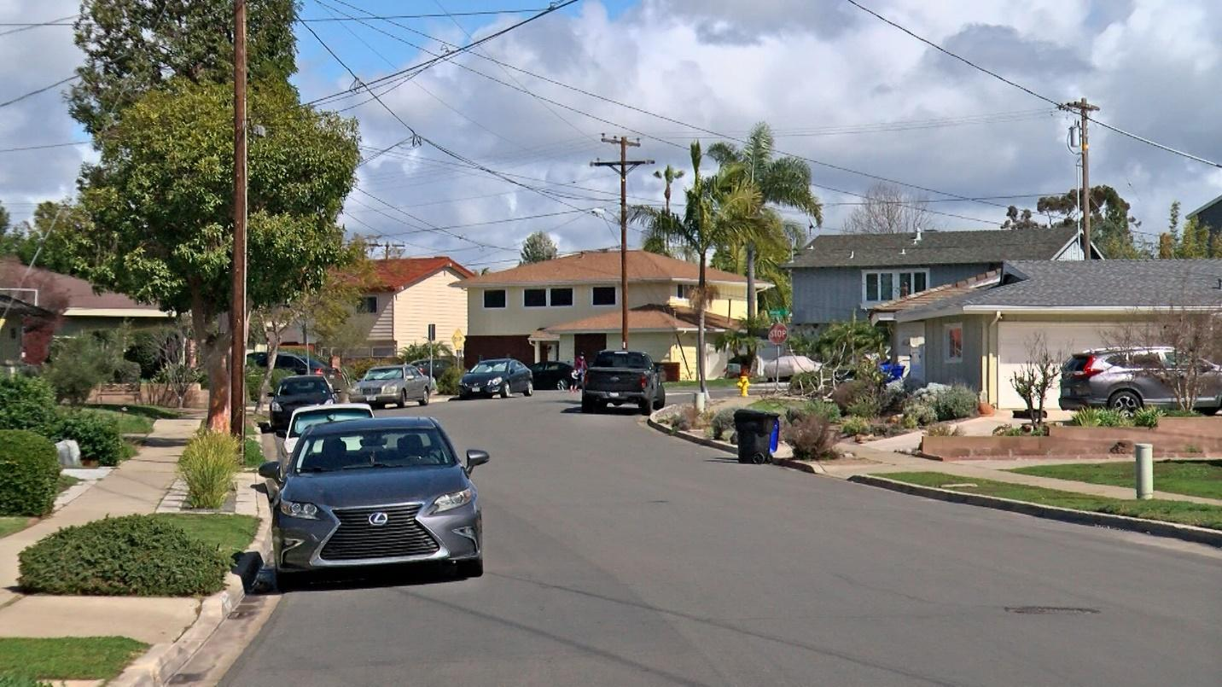

🚗 From Interstate 805 (I-805)

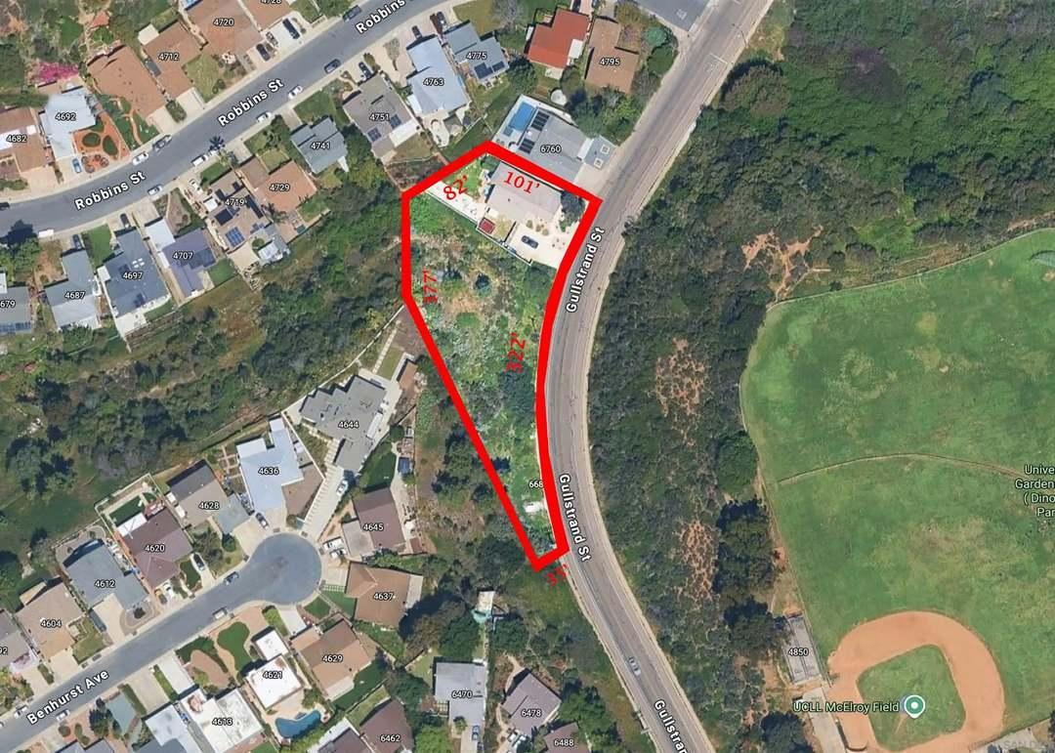

- Take Exit 23 for Governor Drive
- Head west on Governor Drive
- Turn right onto Gullstrand Street
- Turn right onto Florey Street
- Turn left onto Bovet Way
- The home will be on your left

🚗 From San Diego International Airport (SAN)
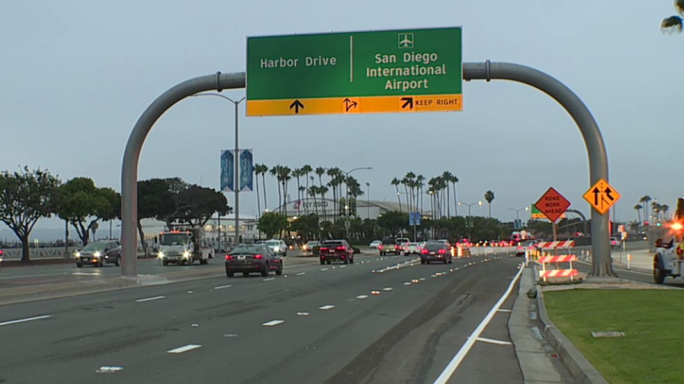

- Exit the airport via North Harbor Drive
- Merge onto I-5 North
- Take Exit 29 (Genesee Avenue)
- Follow the same steps as I-5 directions above
⏱️ Approximate drive time: 15–20 minutes (depending on traffic)

💡 Helpful Tips for Guests
- GPS/Waze works well — just enter the full address:
- 7405 Bovet Way, San Diego, CA 92122, USA
- Neighborhood streets are quiet residential roads, please drive slowly
- Street parking may be limited, so follow provided parking instructions
- Peak traffic times: 7–9 AM & 4–6 PM

🚗 Parking Instructions
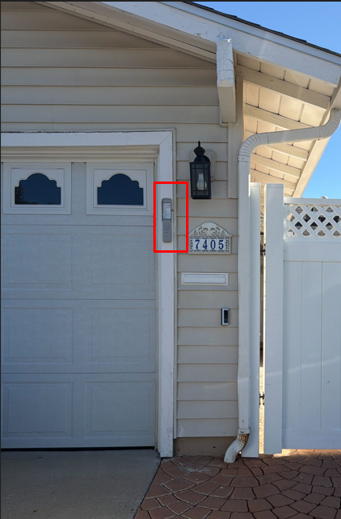

- There are two parking spaces available in the driveway.
- Street parking is also available, but we kindly ask that you park only in front of the house, as neighbors can be sensitive about parking in other areas.
Important Rules:
- Follow the 72-hour parking rule
- Observe street sweeping schedules
- Do NOT park within 20 feet of crosswalks

🔑 How to Open the Front Door

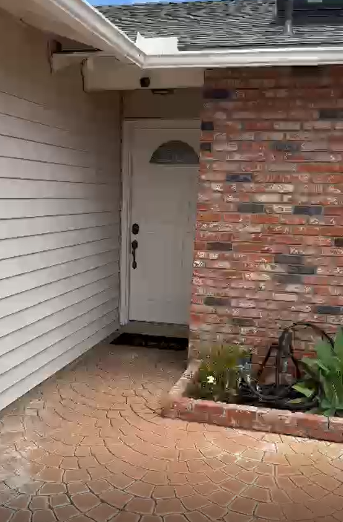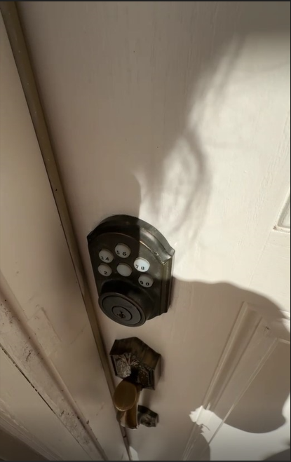
🚪 Step-by-Step Instructions

Locate the keypad lock
You’ll see a round-button keypad above the door handle
Enter your access code
Press the numbers on the keypad one by one
Make sure to press each button firmly
Push the knob (just below the keypad)
This unlocks the deadbolt
Open the door

🔒 How to Lock the Door
Close the door fully
Press the center button to reset the keypad

📶 WiFi Access
Network: 7405 Bovet Way
Password: littlewater437
Note: The password is case-sensitive.

📍 You’ll find the router in the back left bedroom, positioned near the hallway beside the gray sleeper chair.
🔧 Quick Troubleshooting Tips
If you’re having trouble connecting:
✔️ Double-check the network name and password
✔️ Make sure WiFi is turned on in your device
✔️ Move closer to the living room for a stronger signal
✔️ Turn WiFi off and back on
✔️ Restart your device

🔌 Restarting the Router (If Needed)
If the connection is still slow or not working:
✔️ Locate the router in the living room
✔️ Unplug the power cable
✔️ Wait 30–60 seconds
✔️ Plug it back in
✔️ Wait 2–3 minutes for the internet to fully reconnect

🎒 What to Bring (Quick Tips)
We’ve got the basics covered, but here are a few things guests usually appreciate bringing:
- Your favorite toiletries (we provide a starter set including:
- Toiletries (starter set)
- Paper towels
- Bath tissue
👉 For longer stays or personal preferences, you may want to bring extras.
- Phone chargers & devices
- Camera (the views are worth it!)

🍔 Food Delivery Made Easy
Staying in? You can have food delivered right to your door!
Uber Eats or DoorDash:
- Open the app or website
- Enter the address: 7405 Bovet Way, San Diego, CA 92122, USA
- Choose your food
- Place your order and track it in real time
Helpful Tips:
- Keep your phone nearby for driver updates
- Add notes like “Front door is up the stairs”
- Order early during busy hours

⏳ Top 3 Places if You Arrive Early
☕ 1. Blue Bottle Coffee UTC

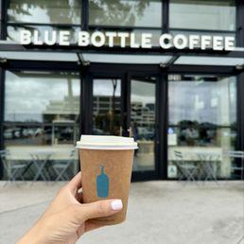

📍 Address: 4545 La Jolla Village Dr, San Diego, CA 92122
🚗 Distance: ~2.5 miles | ⏱️ 7 mins drive
Modern, minimalist café known for high-quality coffee and a relaxing vibe—perfect first stop after a long trip.

☕ 2. Starbucks
4.2•Coffee shop•Open
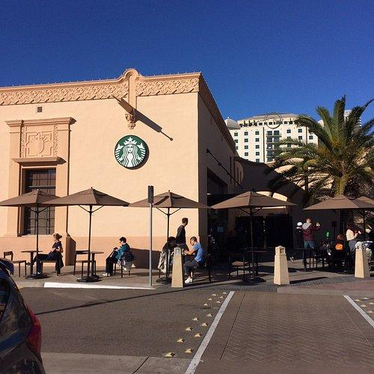

📍 Address: 3202 Governor Dr, San Diego, CA 92122
🚗 Distance: ~0.8 miles | ⏱️ 3 mins drive
Closest and most convenient option—great for a quick coffee or snack while waiting.

🛍️ 3. Westfield UTC
📍 Address: 4545 La Jolla Village Dr, San Diego, CA 92122
🚗 Distance: ~2.5 miles | ⏱️ 7 mins drive
Beautiful open-air mall with restaurants, shops, and plenty of places to relax while you wait for check-in.

📍 Nearby Attractions
🌊 La Jolla Cove
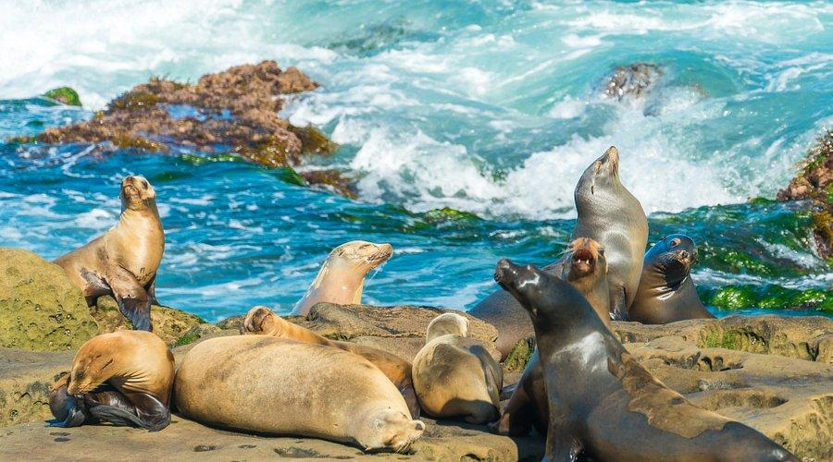

- 📍 La Jolla Cove
- 🚗 ~6 miles | ⏱️ 12–15 mins drive
A must-visit coastal spot known for its crystal-clear water, sea lions, and snorkeling. It’s one of the most iconic beaches in San Diego and perfect for photos or a relaxing walk.

🐠 Birch Aquarium at Scripps

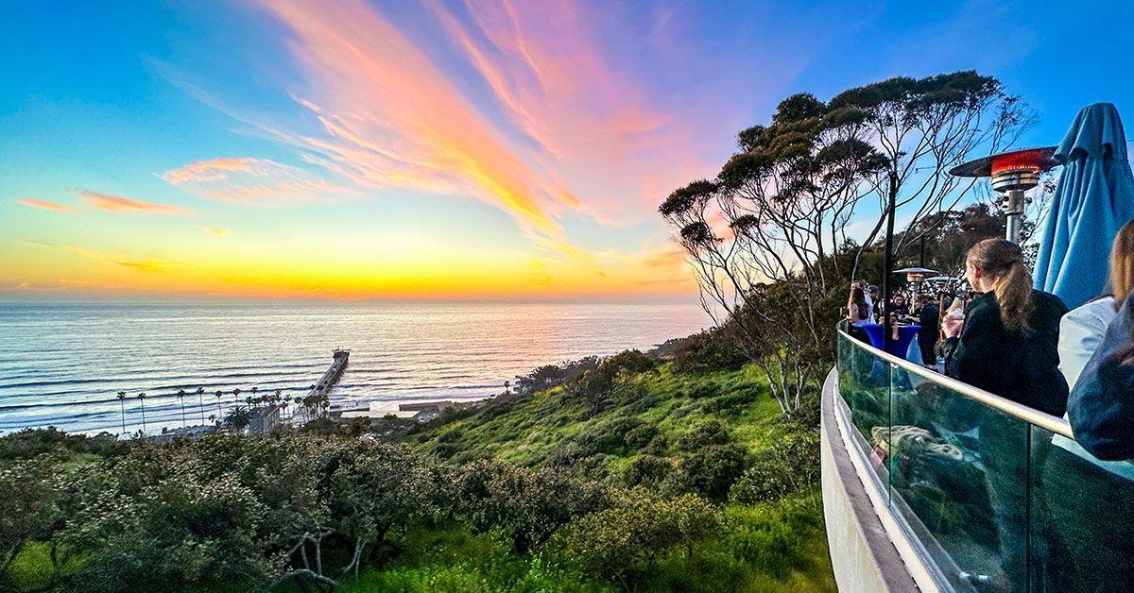
- 📍 Birch Aquarium at Scripps
- 🚗 ~4 miles | ⏱️ 10 mins drive
A family-friendly attraction featuring 60+ exhibits of marine life, interactive tide pools, and ocean views from the cliffs. Great for both kids and adults.

🌴 La Jolla Shores Beach

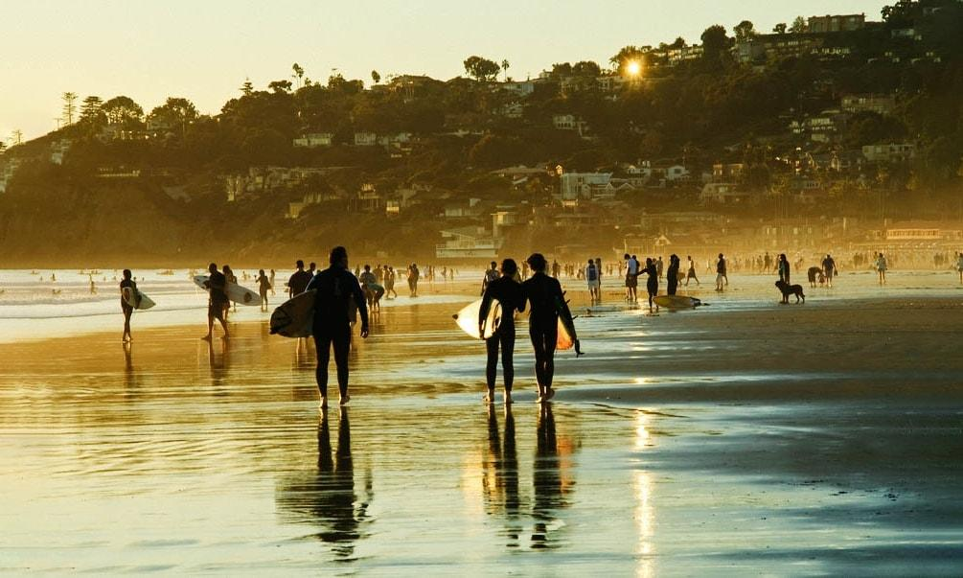
- 📍 La Jolla Shores Beach
- 🚗 ~5 miles | ⏱️ 10–12 mins drive
A wide sandy beach perfect for swimming, kayaking, and relaxing. It’s also part of a protected marine area rich in sea life.

🌄 Torrey Pines State Natural Reserve


- 📍 Torrey Pines State Natural Reserve
- 🚗 ~7 miles | ⏱️ 15 mins drive
One of the most beautiful natural areas in San Diego, offering coastal hiking trails, ocean views, and unique landscapes.

🎓 UC San Diego (UCSD)
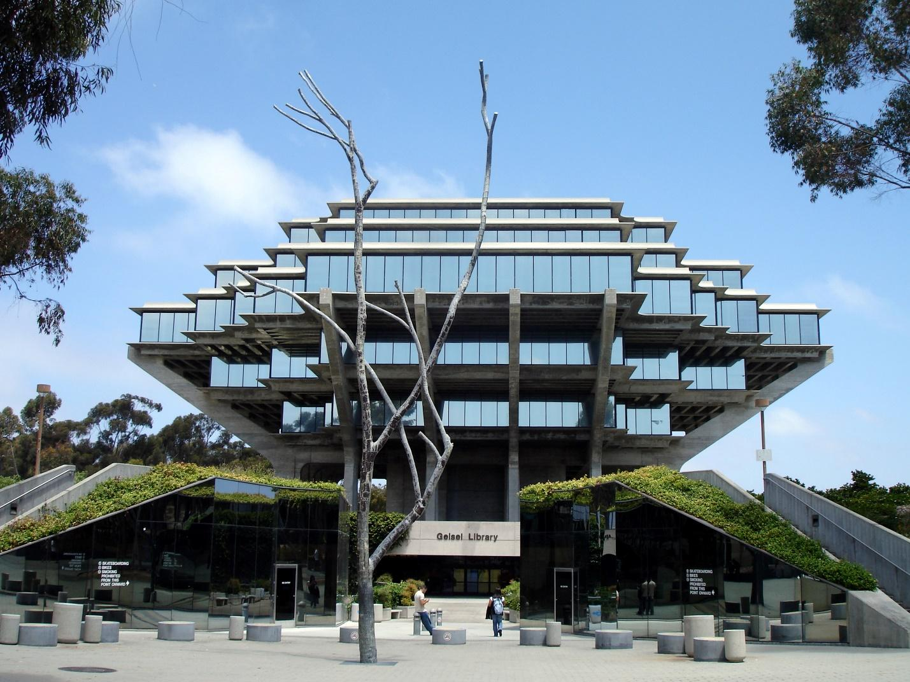
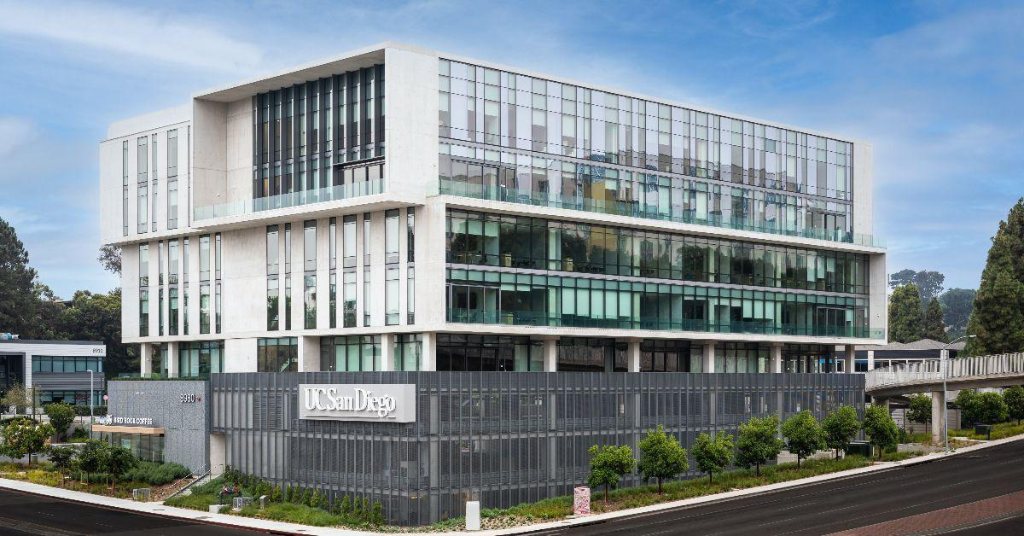

- 📍 University of California San Diego
- 🚗 ~3 miles | ⏱️ 7 mins drive
Explore the beautiful campus, including the famous Geisel Library and unique outdoor art installations.

🍽️ Top 4 Restaurants
🍔 Eureka!


📍 4353 La Jolla Village Dr, San Diego, CA 92122
🚗 ~2.3 miles | ⏱️ 6–7 mins
A local favorite for gourmet burgers, craft beer, and a lively atmosphere—great for casual dining or group meals.

🥗 True Food Kitchen


📍 4303 La Jolla Village Dr, San Diego, CA 92122
🚗 ~2.5 miles | ⏱️ 7 mins
Perfect if you’re looking for healthy, fresh, and flavorful meals with plenty of vegetarian and vegan options.
🦞 Pacific Catch
4.4•Seafood restaurant•Closed
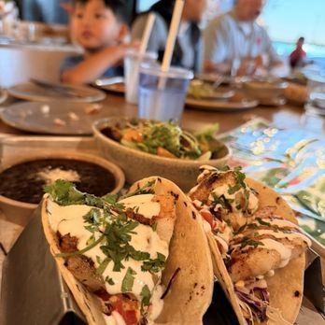

📍 4575 La Jolla Village Dr Suite 1160, San Diego, CA 92122
🚗 ~2.5 miles | ⏱️ 7 mins
A great spot for fresh seafood, poke bowls, and coastal-inspired dishes in a relaxed setting.

🌺 Duke's La Jolla
4.5•Hawaiian restaurant•Closed
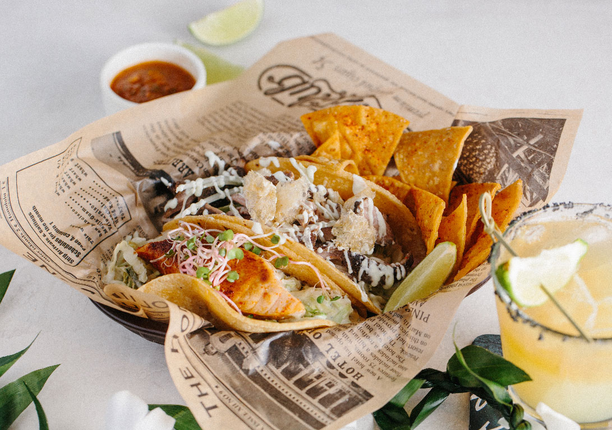
📍 1216 Prospect St, La Jolla, CA 92037
🚗 ~6 miles | ⏱️ 12–15 mins
One of the best dining experiences in the area—ocean views + Hawaiian-inspired cuisine. Perfect for sunset dinners.

🛒 Grocery Stores

🛍️ Ralphs
📍 ~2.2 miles | ⏱️ 6 mins drive
Your closest full-service grocery store with everything you need—fresh produce, meat, pantry items, and household essentials. Ralphs is a major supermarket chain widely used by locals.

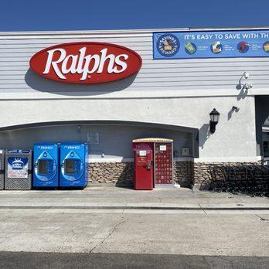

🛍️ Trader Joe’s
📍 ~2.2 miles | ⏱️ 6 mins drive
A guest favorite for unique snacks, ready-to-eat meals, and organic options—great for quick and affordable shopping. Trader Joe’s is a popular grocery option in San Diego shopping areas.

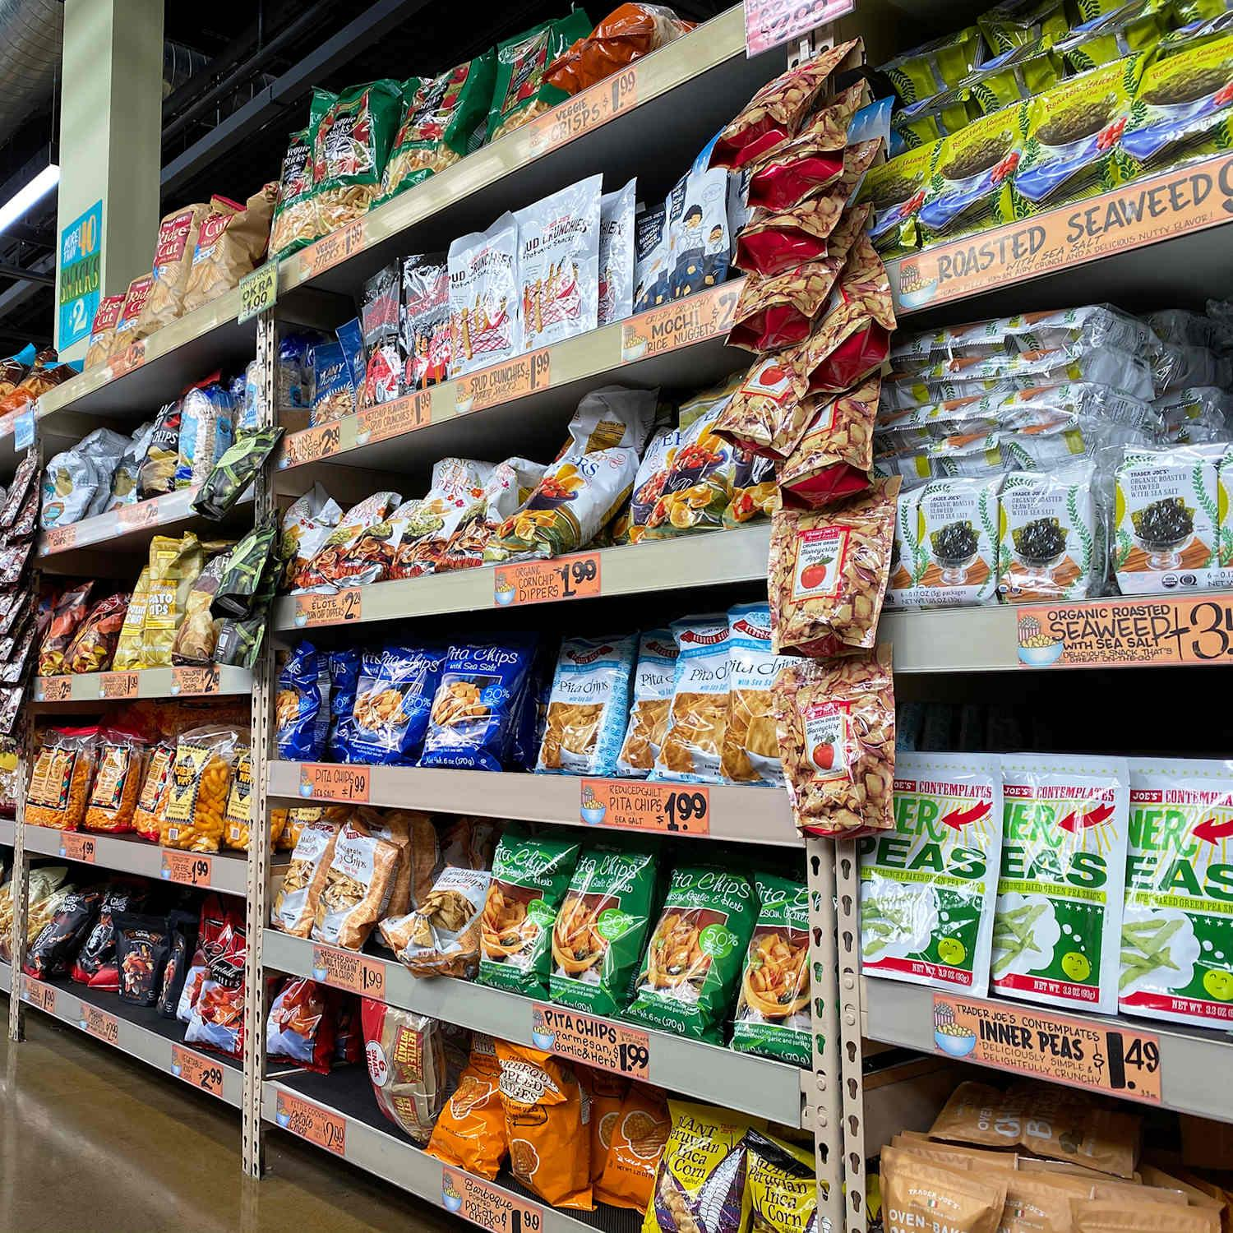

🛍️ Vons

📍 ~1.5 miles | ⏱️ 4 mins drive
A convenient neighborhood grocery store offering fresh produce, bakery items, deli, and everyday essentials—perfect for quick stops.



💡 Tip
- All stores offer delivery via apps like Instacart if you prefer to stay in
- For quick essentials, Vons is the closest
- For variety and better pricing, Ralphs or Trader Joe’s are great options

🚑 Medical & Emergency Information
🚨 Emergency Services
- 📞 Call 911 for police, fire, or medical emergencies
- Available 24/7 throughout San Diego

🏥 Nearest Hospitals
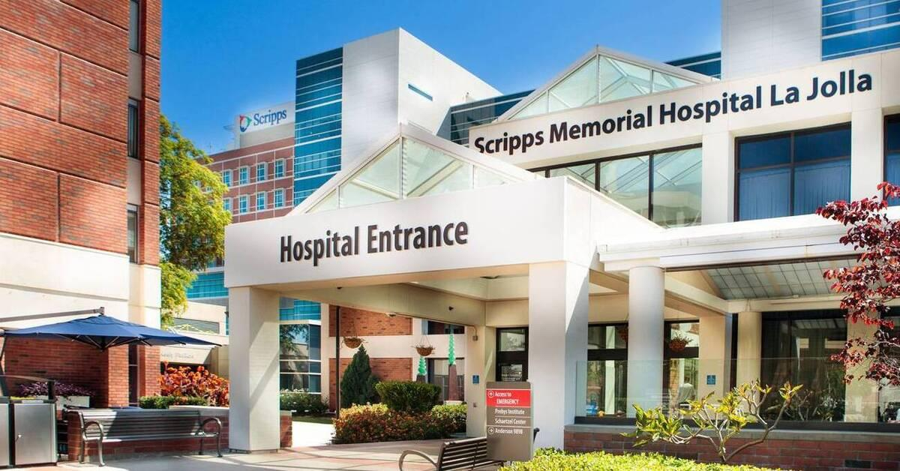
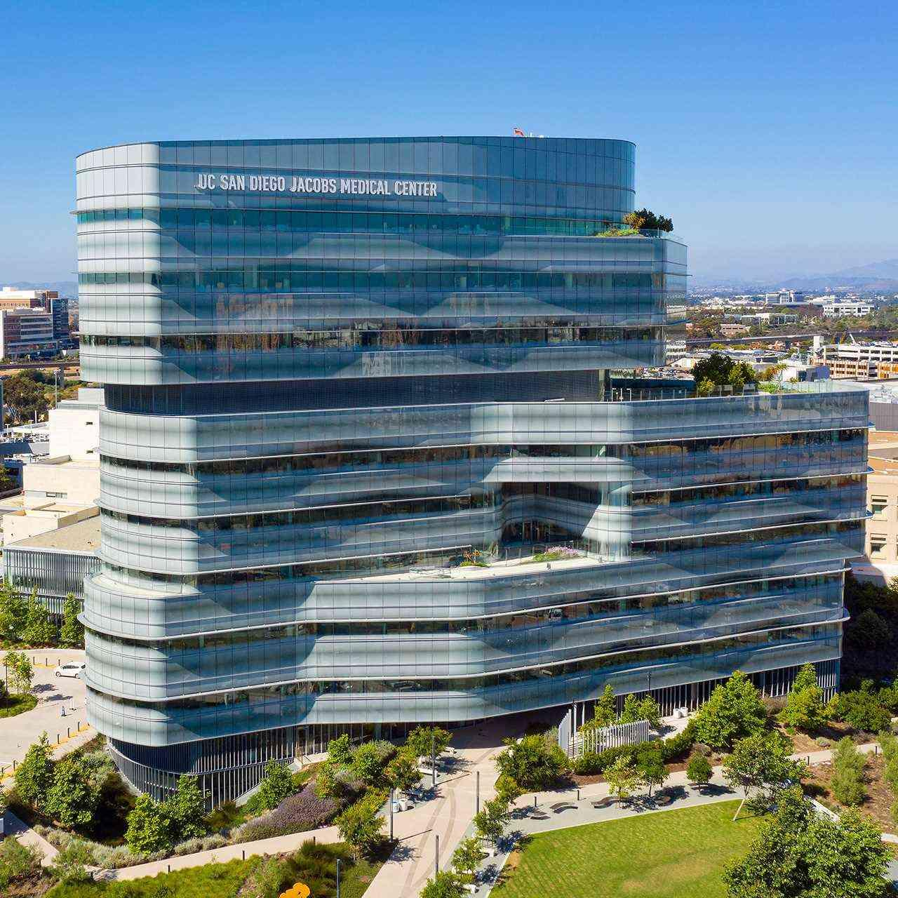
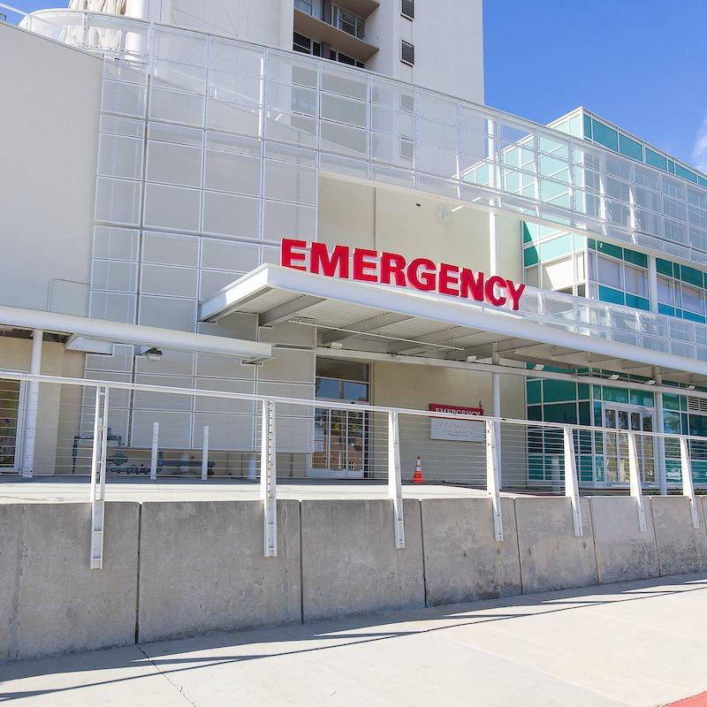
- 🏥 Scripps Memorial Hospital La Jolla
📍 ~3 miles | ⏱️ 7–10 mins drive
Full-service hospital with 24/7 emergency care
- 🏥 UC San Diego Health – La Jolla
📍 ~3 miles | ⏱️ 7–10 mins drive
Highly rated medical center and trauma care

💊 Nearby Pharmacies
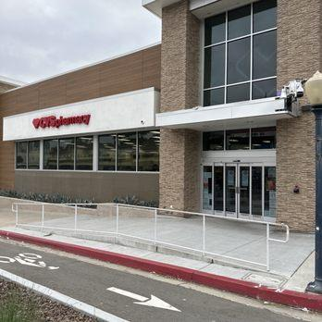

- 💊 CVS Pharmacy
📍 ~1–2 miles | ⏱️ 5 mins drive
Prescriptions, over-the-counter meds, and essentials
- 💊 Walgreens
📍 ~2–3 miles | ⏱️ 6–8 mins drive
Open late with a wide range of health supplies

🩺 Urgent Care (Non-Emergency)
- 🩺 Scripps Clinic Urgent Care
📍 ~4 miles | ⏱️ 10 mins drive
Best for minor illnesses or injuries without ER wait times

💡 Helpful Tips
- For life-threatening emergencies → Call 911 immediately
- For minor concerns → urgent care is usually faster and more affordable than ER
- Most pharmacies carry basic essentials like pain relievers, cold medicine, and first aid

👮‍♂️ Nearest Police Station
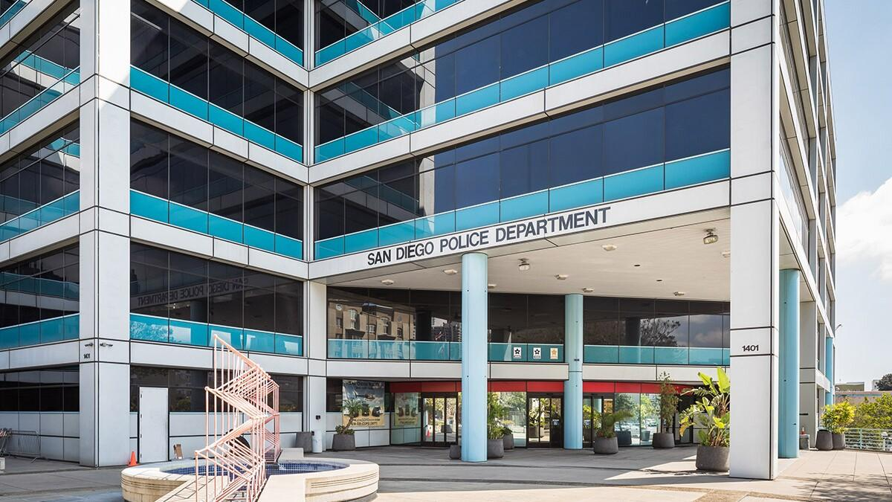

🚔 San Diego Police Department – Northern Division
📍 ~6 miles | ⏱️ 12–15 mins drive
This is the nearest police station serving the University City area. Officers here handle non-emergency reports, lost items, and general assistance.

🚨 Emergency
- 📞 Call 911 for any immediate danger or urgent assistance
📱 Non-Emergency Line
- 📞 (619) 531-2000
Use this number for noise complaints, minor incidents, or general inquiries

💡 Helpful Tips
- For urgent situations, always call 911 first
- For non-urgent concerns, the non-emergency line is the fastest option
- Please help keep the neighborhood safe by reporting anything unusual

